Reflection: Sixian Qi

Role & Contribution:

* Design E-R Diagram
* Implement DB, Data, Migration, Repository Pattern
* Implement Controllers
* Implement Admin Controllers

Challenges and how I handled it:

1. Add filter feature to Repository Pattern

I needed to understand how the default DbContext works and how the Repository Pattern operates in order to successfully implement custom filtering logic.

1. Refactor Customer Model to inherit from IdentityUser

I encountered a FOREIGN KEY constraint failed error during migration. To resolve it, I deleted the database, revised the seeding strategy (since user passwords cannot be seeded directly in AppDbContext), and then ran the migration again.

1. SQLite cannot sort by decimal data type

I handled this by adding custom sorting logic in the Repository Pattern to bypass the limitation.

Reflection: Angran Li

Role & Contribution:

* Design E-R Diagram
* Implement Views
* Implement User feature
* Implement AI assistant

Challenges and how I handled it:

1. How to modify Identity default UI pages to add listing user’s property feature

I studied how Razor Pages works and how the default Identity UI are structured in order to add functionality for users to view and manage their own property listings.

1. Improving View Layout and Aesthetics

I used Bootstrap’s grid system and Razor syntax to structure the layout. I also applied CSS to customize the color palette and added a background image and an introductory video to the index page for a better user experience.

1. Add AI agent

Understood how the ChatGPT API works and integrated an AI assistant into the application.

Fully functional application Screenshots:

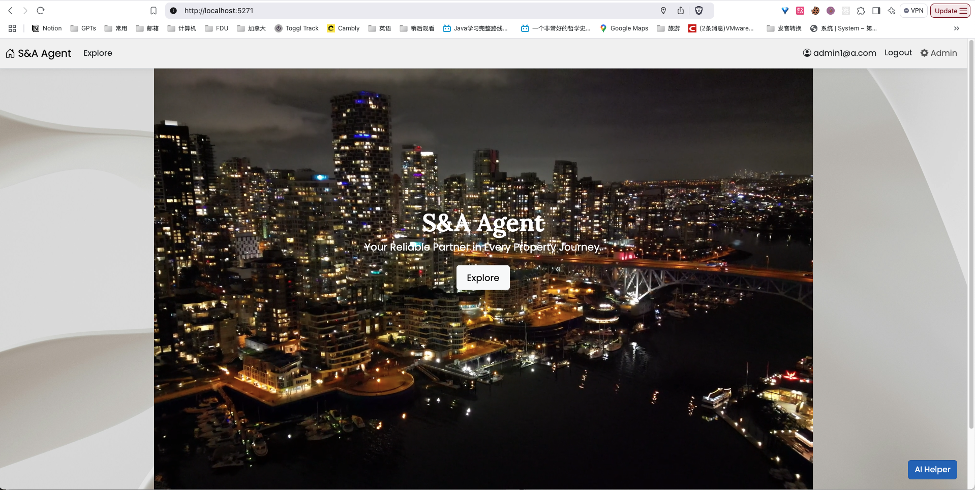

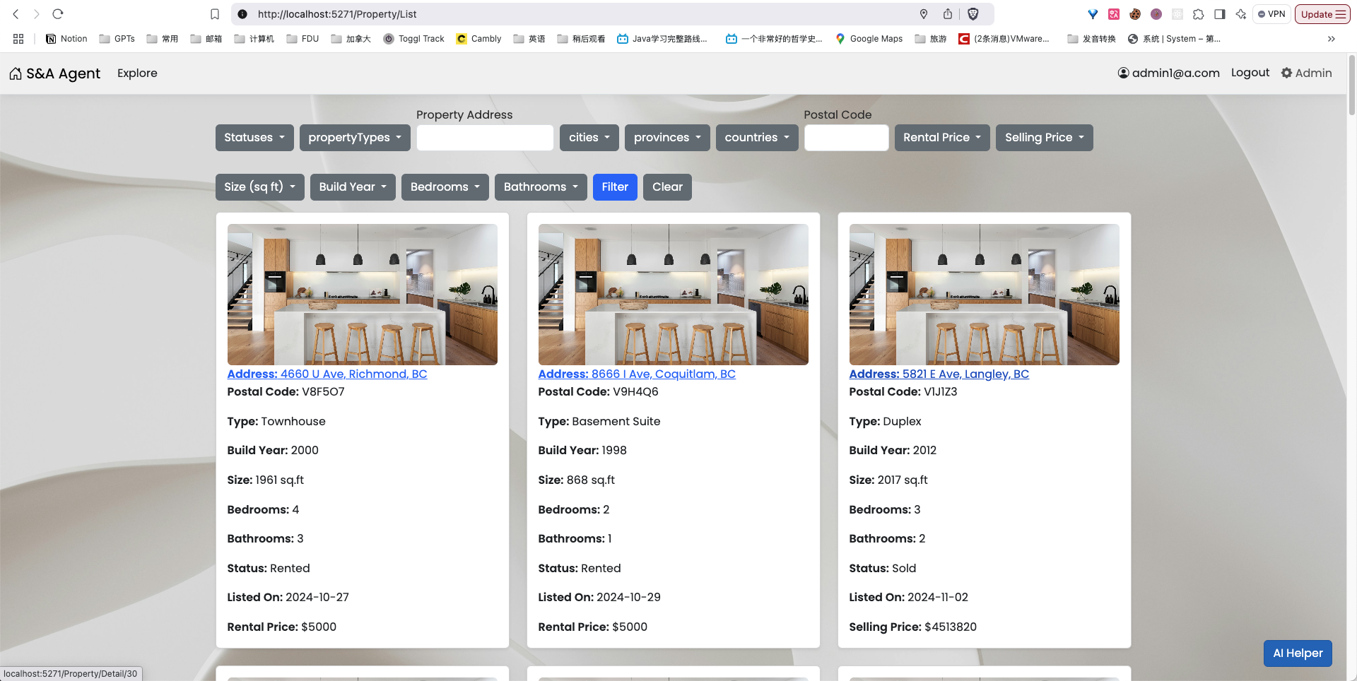

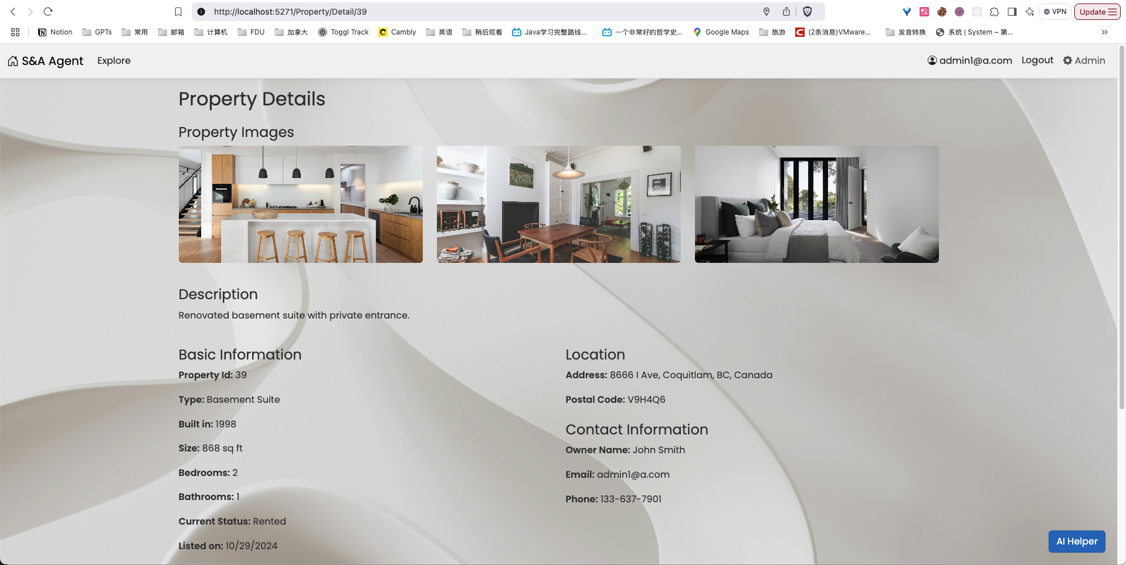

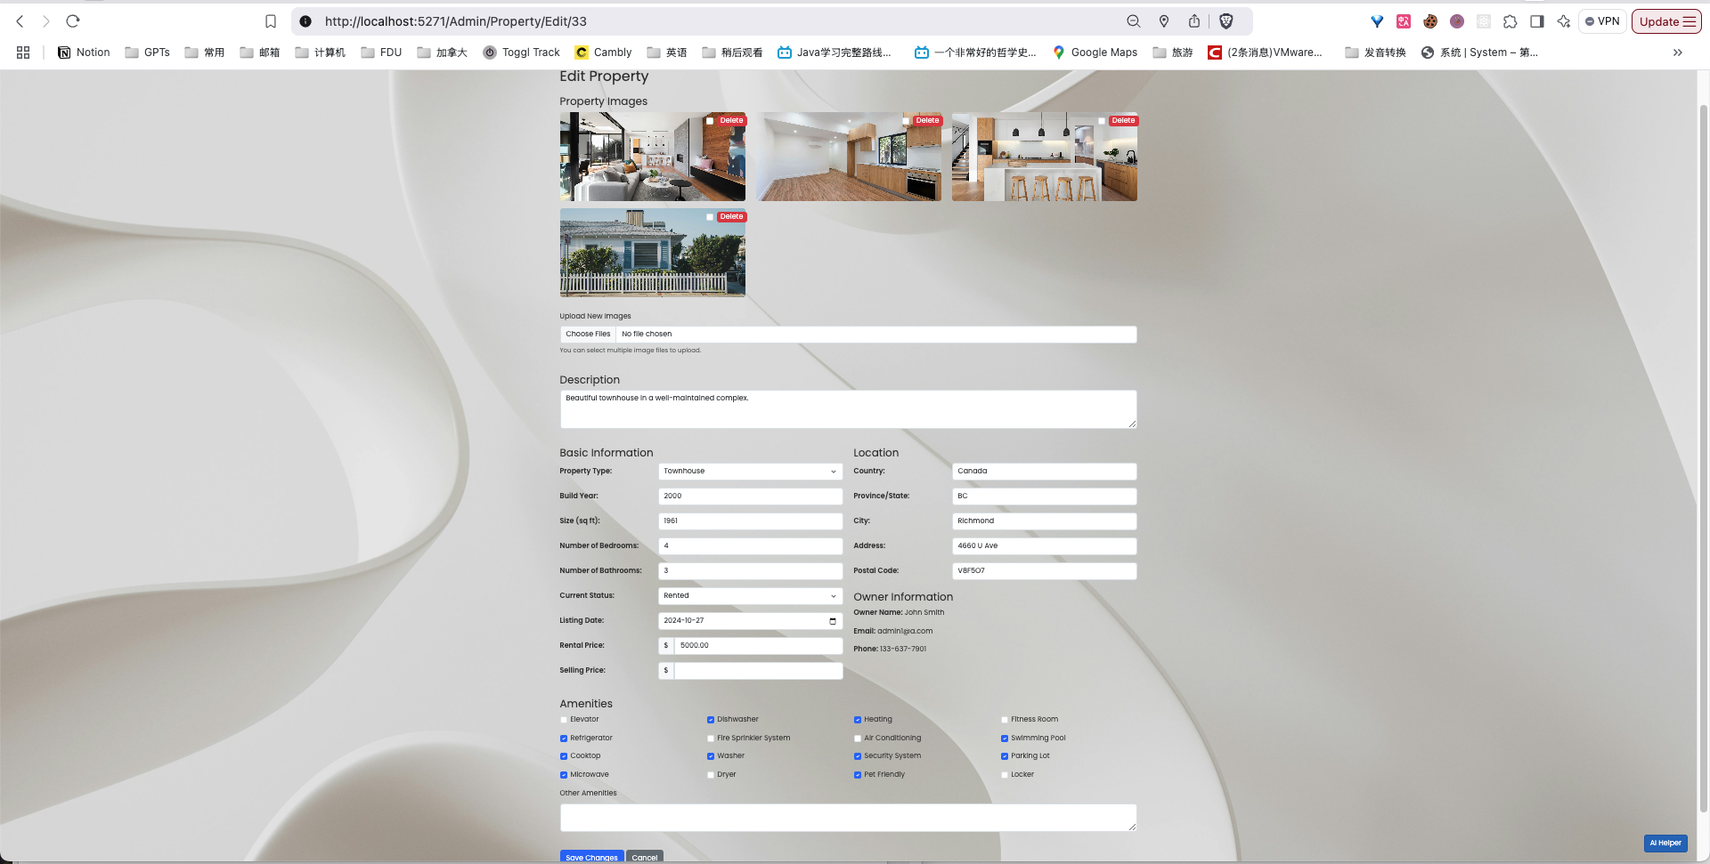

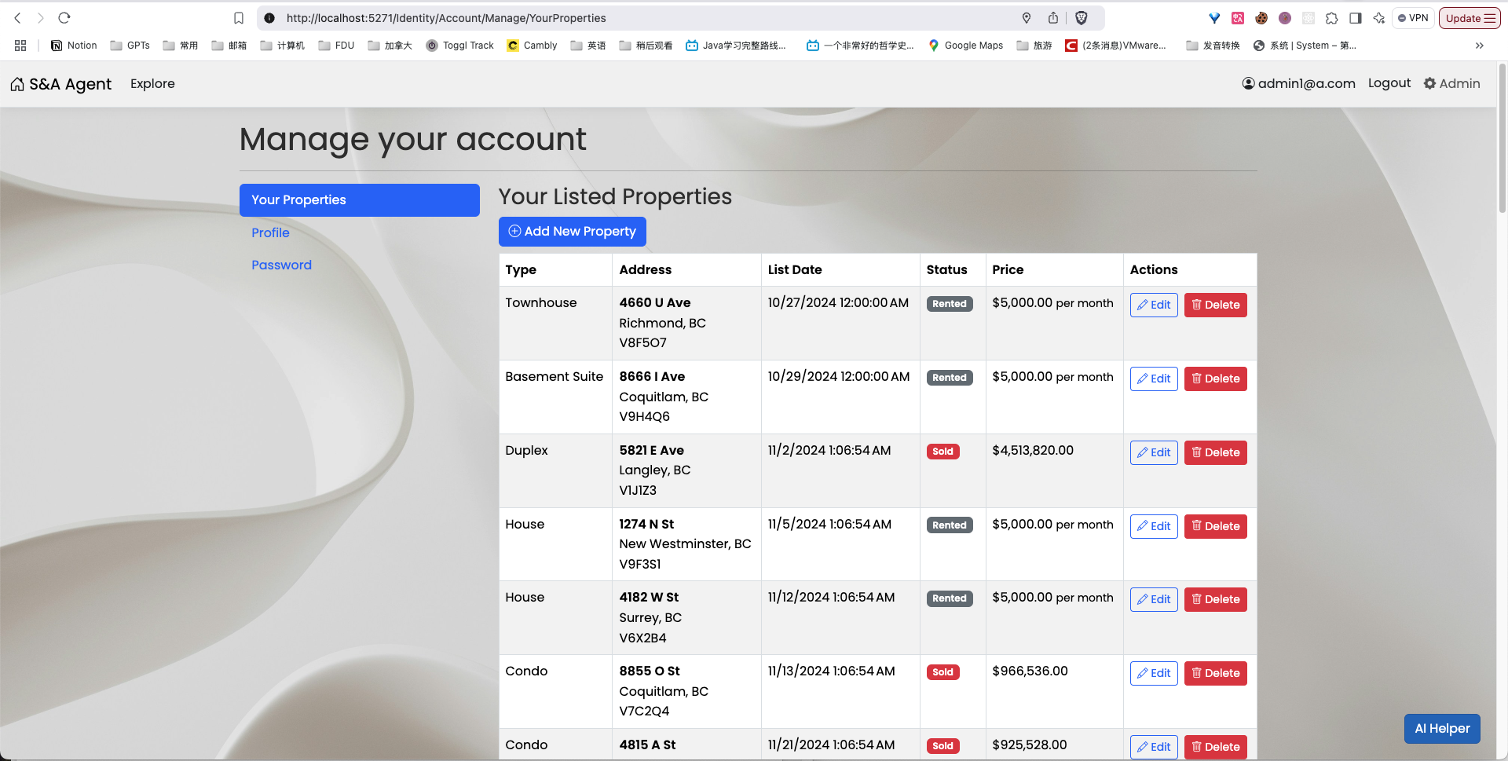

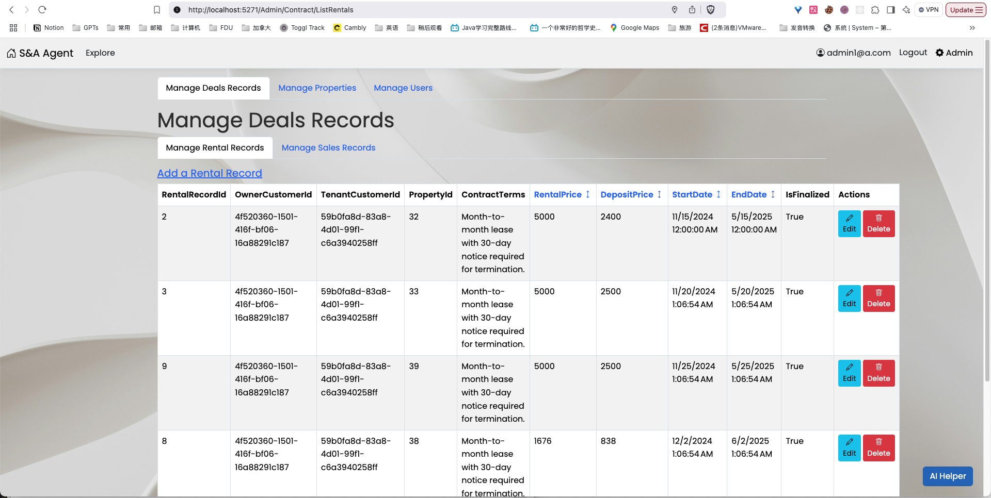

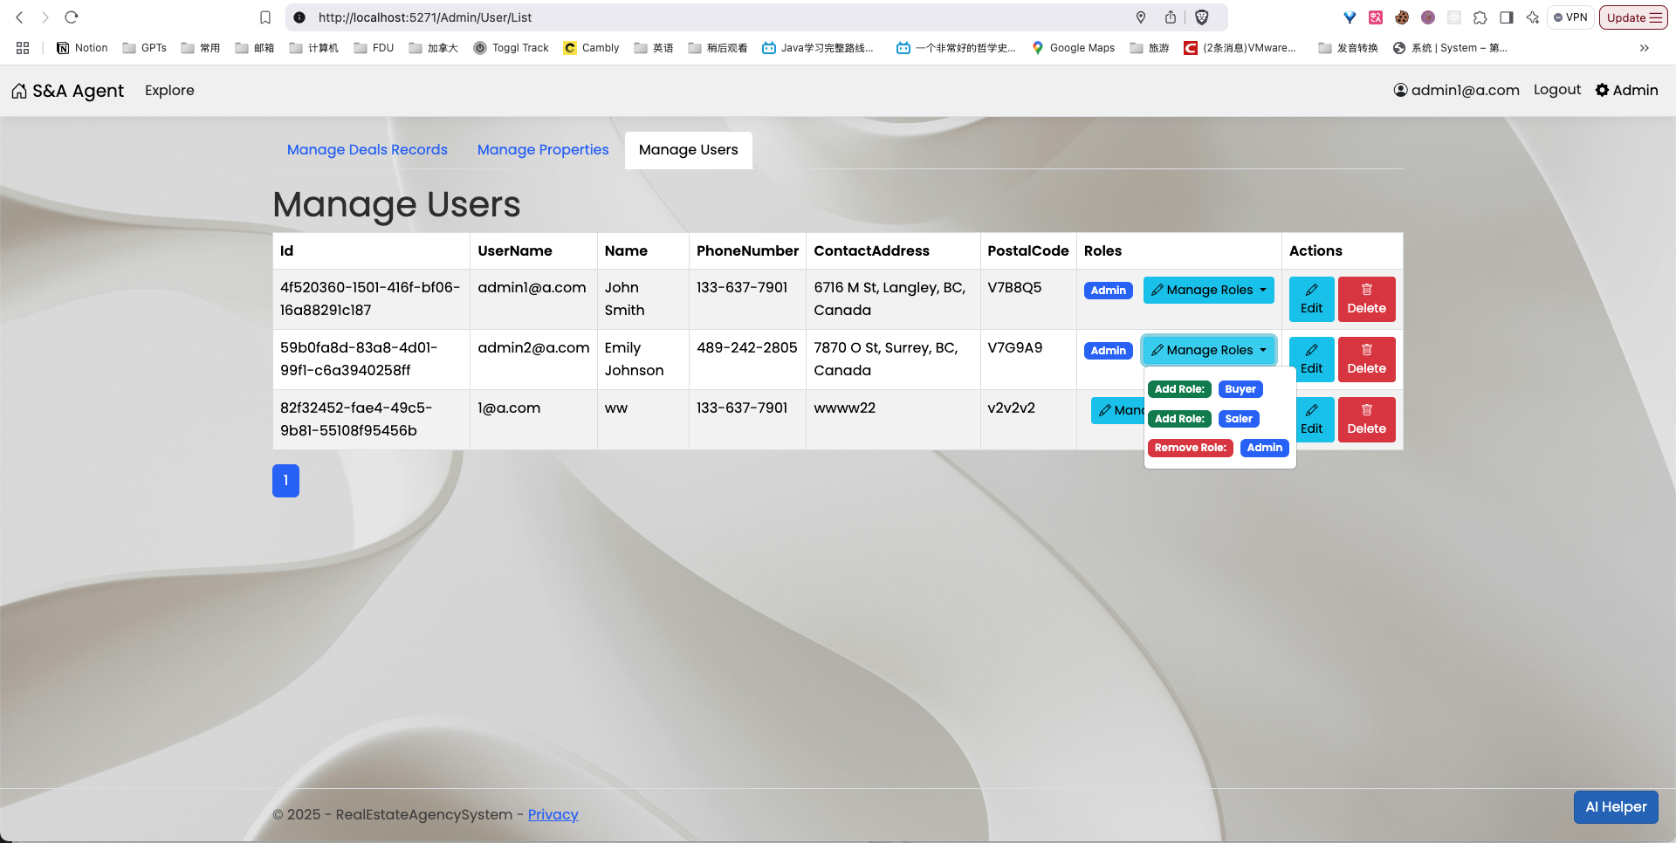

List of references and resources

1. <https://learn.microsoft.com/en-us/ef/core/>
2. <https://learn.microsoft.com/en-us/dotnet/api/microsoft.aspnetcore.identity?view=aspnetcore-9.0>
3. <https://learn.microsoft.com/en-us/aspnet/core/razor-pages/?view=aspnetcore-9.0&WT.mc_id=dotnet-35129-website&tabs=visual-studio>
4. <https://getbootstrap.com/docs/5.3/getting-started/introduction/>
5. <https://icons.getbootstrap.com/>